The AI Professional

(COSC2778)

Final Report

Remote Patient Monitoring System

**Data Buzz**

Nitin Tundwal, Christangel Fargose, Mark Pereira, Shonil Dabreo

RMIT University

Nitin ([s3572060@student.rmit.edu.au](mailto:s3572060@student.rmit.edu.au))

Christangel ([s3794800@student.rmit.edu.au](mailto:s3794800@student.rmit.edu.au))

Mark ([s3797413@student.rmit.edu.au](mailto:s3797413@student.rmit.edu.au))

Shonil ([s3835204@student.rmit.edu.au](mailto:s3835204@student.rmit.edu.au))

**24th May 23, 2021**

Table of Contents

**Introduction** 3

**Problem Definition** 3

**Significance** 4

**Proposed AI-driven Solution** 6

**Ethical Considerations of RPM Systems** 6

**1.** **Fairness** 7

**2.** **Privacy** 7

**3.** **Transparency** 7

**4.** **Data Security** 7

**Technical issues** 7

**Methodology** 8

**Conclusion** 9

**References** 10

**Table of Figures**

**Figure 1. Chronic Diseases impacted by COVID-19** 4

**Figure 2. Situations due to COVID-19 in Urban and Rural areas**. 5

**Figure 3. Integration of the RPMS system** 8

# **Introduction**

Before the pandemic, there have been advances in telehealth to provide valuable health care. Wearable devices vendors introduced wearable devices in the market for people to focus on their fitness by tracking their heart rate. Wearable devices didn’t come out helpful for patients having diseases like diabetes, cancer, etc.

The covid-19 pandemic severely affected the people, to which, in response, governments put out restrictions to prevent the spread of the virus. Quarantining the chronically ill patients became more vital as they were considered high risk for covid-19. However, sick people needed frequent check-ups to keep up with their health.

The objective is to create an e-health derived Remote Patient Monitoring System to provide valuable health care. RPMS is an initiative for tracking the health condition of sick people. Through RPM, the ill people would be able to remotely participate and be responsible for examining their health at ease. Moreover, the RPM consumers will be able to avail of other benefits such as instructions for using the system, feedback & aid in improving their health. Transparency will allow them to understand their health conditions in-depth, and they then can proactively control their care plan.

The patients, medical care workers, and department of health would be the stakeholders to bolster the use of this system.

# **Problem Definition**

The covid pandemic has caused a devastating impact on the lives of people. The recent lockdown imposed to contain the covid has prevented ill people from assessing their health. Long-term disordered people require surveilling over their health condition. Remote Patient Monitoring Systems can be used to monitor people with severe diseases for better health outcomes.

People with prolonged diseases such as diabetes, cancer, hypertension, etc., who require consistent health assessment have been affected the most due to the covid restrictions. Moreover, medical checkups for ordinary people have also been discouraged.

An AI-based system would allow ill patients to remotely access and engage in improving their health, especially during the covid. In everyday situations, sick people would avoid unnecessary hospital visits or minimize crowding in the waiting room. Additionally, this will help old aged, ill people who cannot move by themselves to get examined at home.

# **Significance**

We all are aware of the disaster COVID-19. This pandemic has affected us in more than one way. We have been involved economically, mentally, and physically by the covid-19 pandemic. Moreover, the patients who had chronic diseases were left to succumb to them, as most governments diverted the healthcare resources to COVID-19. This diversion of the healthcare resources disrupted the routine care necessary for chronic disease patients.

The article authors undertook several surveys during the pandemic. We will now look at a few of them and get into the depth of this problem.

Elsevier Public Health Emergency Collection is an organisation that conducted a survey online in which 202 HCPs (Healthcare Professionals) from 47 countries participated in the given period, that is, March 31 and April 23, 2020. There was a questionnaire consisting of 6 multiple-choice questions.

* The survey found that Diabetes-38% is the condition most affected by the diversion of healthcare resources to COVID-19, followed by chronic obstructive pulmonary disease-9%, hypertension-8%, heart disease-7%, asthma-7%, cancer-6%, and depression-6%.
* Moreover, it can be seen from the survey that COVID-19 also affected the co-occurring chronic disease like diabetes and hypertension.

Snap of the survey by Elsevier Public Health Emergency Collection is given below:

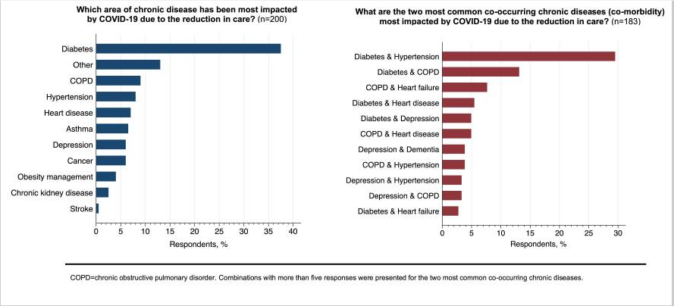Figure 1. Chronic Diseases impacted by COVID-19

**Source**: .2021.[image] Available at: <[https://www.ncbi.nlm.nih.gov/core/lw/2.0/html/tileshop_pmc/tileshop_pmc_inline.html?title=Click%20on%20image%20to%20zoom&p=PMC3&id=7308780_gr1_lrg.jpg>](https://www.ncbi.nlm.nih.gov/core/lw/2.0/html/tileshop_pmc/tileshop_pmc_inline.html?title=Click%20on%20image%20to%20zoom&p=PMC3&id=7308780_gr1_lrg.jpg%3e)

[Accessed 20 May 2021].

The above survey gives a tiny picture of the current situation, whereas the actual image is quite extensive. Moreover, many low-income country populations do not have access to modern technologies, which makes it far more difficult for chronic disease patients to curb COVID-19 as it will take time for them to get used to the Remote Monitoring system.

Let us take a look at another survey published by BMC Public Health in India. This survey was conducted last year between July 29 to September 12, 2020, in which 1,734 people participated through telephonic interviews.

People in India have worsened in the last few weeks due to COVID-19. With a total of 25.8M cases and 287K deaths so far, COVID has hit India hard. In this, people who already had chronic diseases were most vulnerable.

Due to disruption in medical resources, the chronic disease patients' condition worsened in both Urban and Rural areas. We could say from a graph that a significant proportion of Rural people are suffering the most. Diabetes symptoms worsened for 19% of Rural and 12% of the Urban populations, whereas Hypertension symptoms worsened for 17% Rural and 10% urban populations.

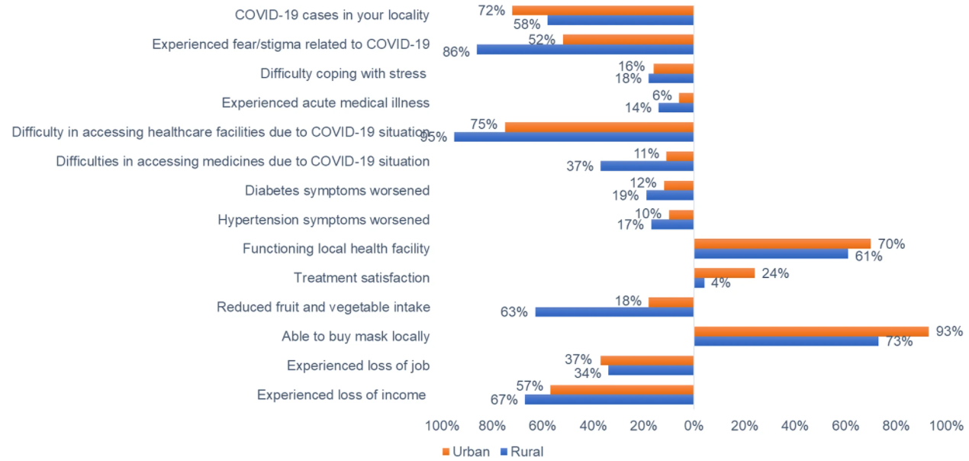Figure 2. Situations due to COVID-19 in Urban and Rural areas.

**Source** - 2021. [image] Available at: <[https://bmcpublichealth.biomedcentral.com/articles/10.1186/s12889-021-10708-w/figures/1>](https://bmcpublichealth.biomedcentral.com/articles/10.1186/s12889-021-10708-w/figures/1%3e)

[Accessed 20 May 2021]

People in rural parts of India faced difficulty in accessing the healthcare facilities for their routine check-ups. Moreover, an economic barrier became a significant factor as nationwide lockdowns were imposed, which restricted any incomes. Coronavirus pandemic has affected healthcare resources and increased mental health problems.

Looking at the above two surveys, the people who have chronic disease are more prone to infectious diseases. As this pandemic requires us to stay indoors and maintain social distance, the Remote Patient Monitoring system would play an integral part in saving lives and serving humanity. These systems can be fitted to the patient, monitoring the patient's health and informing the concerned authorities whenever necessary. Moreover, it would enable doctors to attend to patients virtually, and an AI-enabled application will by itself order their medicines, and they will not have to step out of their home.

We found that the avg annual costs of RPM per patient for installation, monitoring and maintenance fees would be between $1000 USD and $2000 USD. The training of hospital staff would be an additional cost.

# **Proposed AI-driven Solution**

A remote Patient Monitoring System is a proposed solution for real-time tracking of the patient’s health condition to provide high-quality health care.

RPMS combines different applied sciences allowing health care workers to monitor and use patients’ real-time data variations through a treatment strategy. It is a fundamental part of the wide telehealth and e-health application. The RPMS system involves a patient-end smartphone application that records various devices and sensors connected via Bluetooth technology—tracking devices such as Glucose Monitor, Blood Pressure Monitor, Pulse Oximeter, Holter Monitor, Thermometer and more. A mobile app would transfer the information collected using Bluetooth to the cloud server of health care.

The AI system would be pre-installed by providers to prepare the raw gathered data for clinicians. The data would also be made available to the patient-side android app presented with visualizations for patients to understand their health progress better and be motivated. Clinicians would analyze the prepared data using hospital-end web software. The AI-engineered RPM system will keep updating the patients’ progress through its behaviour patterns. The system will alert the officials if a high severity is detected. The AI system would also suggest the doctors as it keeps learning from previous doctors’ informed prescriptions or decisions.

As the patient’s health status is constantly under surveillance, the RPMS systems would identify and solve issues quickly compared to the traditional systems. While staying at home, regularly ill people can keep inspecting their health situation. The RPMS system would save money that patients could have spent on unneeded timely hospital trips. Moreover, the RPMS system will enable people living in remote locations to avail the RPMS benefits. The remote system would let the hospital staff work remotely and be safe while continuing with the patient treatments.

## **Ethical Considerations of RPM Systems**

As witnessed above, Remote Patient Monitoring Systems collect a lot of patients' health information. The system must protect this sensitive information at all times and ensure that this information goes into the trusted hands only. We'll talk about four ethical considerations relevant to our project.

### **Fairness**

Looking at the information sourced from the Centers for Disease Control and Prevention (CDC), chronic diseases are much more prevalent in adults aged 65 and above. However, we also know that some young individuals also suffer from chronic disease such as diabetes. The problem is that our data would not have much information about the young patients having chronic diseases. Thus, our system will lack this information. Therefore, there is incomplete data within the system.

To tackle this issue, we will be adding more data on the young patients.

### **Privacy**

We will be using mobile applications to send the data across the cloud to the desired Health professionals. So, there is a risk of a data breach at either patient's end or the hospital's end. If either end is at loose, we'll be compromising the patient's sensitive information. To overcome these difficulties, we will be encrypting the health data at the patient's end on the mobile application before passing it on to the cloud. Since the information is encrypted, there will be assurance regarding privacy. Encrypting our data will prevent any eavesdropping attacks as well. Moreover, our systems will be HIPAA compliant, which will give our systems authenticity.

### **Transparency**

Like healthcare professionals or system administrators, all the people will receive full training for using the systems. The users, such as the patients, will get a complete education on how or where the healthcare system will use the data. All of the terms and conditions will clearly be explained to the patients by the operators.

### **Data Security**

Devices connected directly to the cloud could send all the information without the need for a mobile application. The hackers can now hack the sensors and alter the sensitive information or steal that sensitive information, leaving the patient at high risk. The engineered system will reduce the opportunity of hacking for hackers as sensors would not be connected to the cloud directly but will be related to the mobile application using Bluetooth technology. The system will also protect patients' sensitive information against potential hackers.

Moreover, Data breaches can happen due to human handling of sensitive information, which is called human error. For this, operators will provide training to the health professionals regarding the privacy obligations they need to follow. Management will give limited authorizations for health care professionals.

## **Technical issues**

A nurse will connect to the patient through a telephone call. There is a possibility that a mobile app could lose a WIFI connection before sending the records to the cloud server. The mobile app will constantly keep on pinging the cloud server and notify the parties if the connection is lost. The mobile app will still run in the background if there is an internet issue as it receives the device readings through Bluetooth. Behind the scenes, the application will encrypt the recorded information in a file. Then the encrypted file would be SMS to the healthcare mobile number that the nurse is using. The family members will receive a text message regarding the internet issue.

# **Methodology**

In the AI-driven solution section, we discussed the working of the whole RPMS system, including patients and hospital staff. We will now discuss the function of each entity involved in the process. Vendors will install the medical equipment at the patient end and educate the patients regarding the usage of the appliances and the mobile app. The user would pair the devices to a smartphone for the exchange of information. The interface between mobile and medical devices will act as a client/server network. The nurse will help patients schedule their appointments and conduct daily check-ups through telephone calls. In response to health signs, a nurse will ask symptom-related questions to understand the case of patients. For visual reference, we can see below the architecture of the RPMS system.

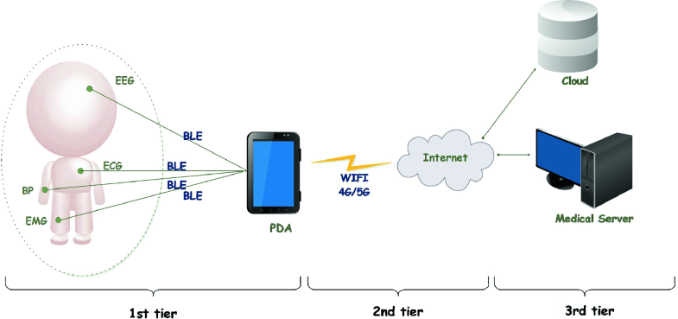

Figure 3. Integration of the RPMS system

**Source** - Remote Health Monitoring Systems Based on Bluetooth Low Energy (BLE) Communication Systems. 2021. [image] Available at: <<https://link.springer.com/chapter/10.1007/978-3-030-51517-1_4>>

[Accessed 21 May 2021].

Vendors will launch a mobile application to receive the readings and send them collectively through the WIFI network. The application will use its cloud server’s API to upload the records. The connection between a mobile app and cloud server will again act as a client-server system. The AI will prepare data received at the cloud server, including the pre-recorded *patient demographic information and their responses to symptom questions*. The cloud system will include statistics and visualizations for patients. E.g., the graphical presentation of the ECG signal. The patient-side mobile application will display simple visualizations to be easily understood. E.g., a temperature bar graph with colour indicators from low fever to high fever.

The clinician will use AI-generated statistics and visualizations to treat the patients. Based on the results, the clinician will contact patients through nurses to assist patients in understanding their conditions, provide emotional support, treatment guidelines and recommend prescriptions. The AI would keep exploring any patterns or trends and alert the officials if any severity is detected. The clinicians would then decide whether a patient is required to visit the hospital for specialized treatment. The system will alert the family members of disabled people.

AI will use the previously prepared data to calculate the fatality and mortality rates based on Age - Gender, symptoms and chronic illness. The predictions will be beneficial during the covid situation where patients with high-risk rate may be given priority over hospitalization.

Considering the procedure described above, this is a feasible, robust and efficient solution that would benefit chronic disease people and health care workers in many ways. All the integrated technologies have a vital role in working in coordination, ensuring the safety and smoothness of the system by using fail-safe mechanisms, primarily when the risk occurs.

Operators will use routine auditing of the systems and feedback systems to evaluate and make further changes. Operators will use guidelines statements to measure the potential risk and to mitigate them.

# **Conclusion**

Our proposed Remote Patient Monitoring System is an all in one deal for the consumers. This RPMS will be the safest way to monitor healthcare in these crucial times as well as for the people living far away from the healthcare facilities. The old aged people or the people suffering from chronic disease who need to be monitored all the time, can be monitored without the need of the physicians. AI enabled RPMS will prove to be more efficient and safer than the older methods. We give the solution which is built taking into account all the ethical concerns like Privacy (encryption of data), Transparency (proper training of the people handling the user data), Data Security (Bluetooth technology for the sensors) and Fairness (adding more data). The RPMS is using an interface in which mobile and medical devices will act as a client/server network. The AI will prepare data received at the cloud server, including the pre-recorded patient demographic information and their responses to symptom questions. The cloud system will include statistics and visualizations for patients. Patients will also be able to view all the visualisations in their mobile application in regards to their health conditions. Moreover, AI will be predicting the fatality and mortality rate based on Age, gender, illness and symptoms which will help prioritizing the hospitalisation of the patients. Therefore, considering all the above points our RPMS will prove to be robust and a life-savior.

# **References**

Jayex.com. 2020. *The rise of Remote Patient Monitoring (RPM) in a COVID-19 world*. [online] Available at: <https://www.jayex.com/en-au/blog/the-rise-of-remote-patient-monitoring-rpm-in-a-covid-19-world>

[Accessed 24 May 2021].

Care innovations. 2021. *What Are the Benefits of Remote Patient Monitoring (RPM) for Patients?​​*. [online] News.careinnovations.com.

Available at: <https://news.careinnovations.com/blog/benefits-of-remote-patient-monitoring-rpm-for-patients>

[Accessed 24 May 2021].

Kennedy, A., 2021. *4 Benefits of Remote Patient Monitoring for Your Practice*. [online] Blog.capterra.com. Available at: <https://blog.capterra.com/benefits-remote-patient-monitoring/>

[Accessed 24 May 2021].

Chudasama, Y., Gillies, C., Zaccardi, F., Coles, B., Davies, M., Seidu, S. and Khunti, K., 2021. *Impact of COVID-19 on routine care for chronic diseases: A global survey of views from healthcare professionals*. [online].

Available at: <https://www.ncbi.nlm.nih.gov/pmc/articles/PMC7308780/>

[Accessed 24 May 2021].

Singh, K., Kondal, D., Mohan, S., Jaganathan, S., Deepa, M., Venkateshmurthy, N., Jarhyan, P., Anjana, R., Narayan, K., Mohan, V., Tandon, N., Ali, M., Prabhakaran, D. and Eggleston, K., 2021. *Health, psychosocial, and economic impacts of the COVID-19 pandemic on people with chronic conditions in India: a mixed methods study*. [online] BMC Public Health.

Available at: <https://bmcpublichealth.biomedcentral.com/articles/10.1186/s12889-021-10708-w#Sec16>

[Accessed 24 May 2021].

Peretz, D., Arnaert, A. and Ponzoni, N., 2021. *Determining the cost of implementing and operating a remote patient monitoring programme for the elderly with chronic conditions: A systematic review of economic evaluations*. [online] SAGE journals.

Available at: <https://journals.sagepub.com/doi/abs/10.1177/1357633X16669239>

[Accessed 24 May 2021].

Mohammadzadeh, N. and Safdari, R., 2014. *Patient Monitoring in Mobile Health: Opportunities and Challenges*. [online].

Available at: <https://www.ncbi.nlm.nih.gov/pmc/articles/PMC4272470/>

[Accessed 24 May 2021].

Choi, D. and Walker, R., 2021. *Remote Patient Management: Balancing Patient Privacy, Data Security, and Clinical Needs*. [online] Karger. Available at: <https://www.karger.com/Article/Fulltext/496312#:~:text=Ethical%20Considerations%20in%20Remote%20Monitoring&text=The%20four%20commonly%20accepted%20principles,part%20of%20their%20clinical%20practice>

[Accessed 24 May 2021].

Fourati, L. and Said, S., 2021. *Remote Health Monitoring Systems Based on Bluetooth Low Energy (BLE) Communication Systems*. [online] Springer Link.

Available at: <https://link.springer.com/chapter/10.1007/978-3-030-51517-1_4>

[Accessed 24 May 2021].

Vitabile, S., Marks, M., Stojanovic, D., Pllana, S., Molina, J., Krzyszton, M., Sikora, A., Jarynowski, A., Hosseinpour, F., Jakobik, A., Ilic, A., Respicio, A., Moldovan, D., Pop, C. and Salomie, I., 2021. *Medical Data Processing and Analysis for Remote Health and Activities Monitoring*. [online] Springer Link.

Available at: <https://link.springer.com/chapter/10.1007/978-3-030-16272-6_7#Abs1> [Accessed 24 May 2021].

AltexSoft. 2020. *Remote Patient Monitoring Systems: Components, Types, Vendors, and Implementation Steps*. [online]

Available at: <https://www.altexsoft.com/blog/remote-patient-monitoring-systems/>

[Accessed 24 May 2021].

ncbi.nlm.nih. 2021.  *Large Controlled Observational Study on Remote Monitoring of Pacemakers and Implantable Cardiac Defibrillators.* [Online]

Available at: <https://www.ncbi.nlm.nih.gov/pmc/articles/PMC4730109/>

[Accessed 24 May 2021].

Reconnect4health.com. 2021. *Telehealth and Remote Patient Monitoring (RPM)*. [online]

Available at: <http://www.reconnect4health.com/wp-content/uploads/2016/07/2013_CAST_Telehealth_and_Remote_Patient_Monitoring_RPM_Case_Studies.pdf>

[Accessed 24 May 2021].

bmchealthservres. 2021. *How to Design a Remote Patient Monitoring System? A French Case Study*. [Online]

Available at: <https://bmchealthservres.biomedcentral.com/articles/10.1186/s12913-020-05293-4. 2021>.

[Accessed 24 May 2021].